1 | Principio del formulario
  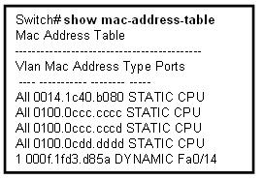
  Refer to the exhibit. Based on the output, which statement is correct?
   | The administrator has manually configured four MAC addresses in the switch.
   | Only VLAN 1 has learned any MAC addresses.
   | The addresses listed as STATIC are each assigned to an Ethernet port.
   | The switch has four loopback interfaces defined.
   | The individual MAC address of port FastEthernet0/14 is 000f.1fd3.d85a and was learned at startup.
2 | Principio del formulario
  What happens when the transport input ssh command is entered on the switch vty lines?
  The SSH client on the switch is enabled.
  Communication between the switch and remote users is encrypted.
  A username/password combination is no longer needed to establish a secure remote connection to the switch.
  The switch requires remote connections via proprietary client software.

3 | Principio del formulario
  What are two key features of an Ethernet switch with Layer 3 capabilities? (Choose two.)
   | Layer 3 routing functions
   | network address translation (NAT)
   | establish remote access connections to remote networks and devices
   | broadcast and multicast traffic management
   | inter-Autonomous System (AS) routing with Border Gateway Protocol (BGP)
4 | Principio del formulario
  Which statement is true about banner configuration on the switch?
  Banners are set in privileged EXEC mode.
  The message of the day banner displays after the login banner, if both are set.
  The command banner login "Authorized personnel Only" causes the configured message to display after the user responds to the username and password prompts.
  The command banner login "Authorized personnel Only" causes the configured message, without the double quotation marks, to display before the user logs in.

5 | Principio del formulario
  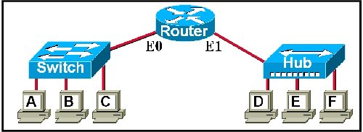
  Refer to the exhibit. The switch and the hub have default configurations, and the switch has built its CAM table. Which of the hosts will receive the data when workstation A sends a unicast packet to workstation C?
  workstation C
  workstations B and C
  workstations B, C, and the E0 interface of the router
  workstations B, C, D, E, F, and the E0 interface of the router
6 | Principio del formulario
  What does pressing Ctrl-N at the CLI do?
  access more recent commands
  disable the command history buffer
  exit configuration mode
  abort the current command entry

7 | Principio del formulario
  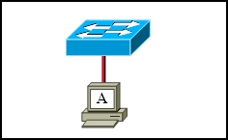
  Refer to the exhibit. The switch and workstation are administratively configured for full-duplex operation. Which statement accurately reflects the operation of this link?
  No collisions will occur on this link.
  Only one of the devices can transmit at a time.
  The switch will have priority for transmitting data.
  The devices will default back to half duplex if excessive collisions occur.
8 | Principio del formulario
  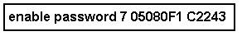
  Refer to the exhibit. The exhibit shows partial output of the show running-config command. The enable password on this switch is "cisco." Which two facts can be determined by the output shown? (Choose two.)
  The enable password is encrypted by default.
  An MD5 hashing algorithm was used on all encrypted passwords.
  The service password-encryption command has been entered on this switch.
  Any configured line mode passwords will be encrypted in this configuration.
  The most secure privileged EXEC mode password possible has been configured on the switch.

9 | Principio del formulario
  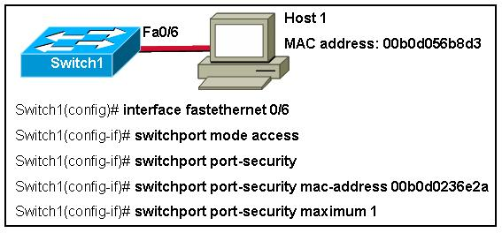
  Refer to the exhibit. What happens when Host 1 attempts to send data?
  Frames from Host 1 are dropped and no log message is sent.
  Frames from Host 1 are dropped and a log message is sent.
  Frames from Host 1 cause the interface to shut down and a log message is sent.
  Frames from Host 1 are forwarded and a log message is sent.
  Frames from Host 1 are forwarded and no log message is sent because the switchport port-security violation command was not configured.
10 | Principio del formulario
  In what mode and for what purpose would the network administrator enter these commands on a switch?
  line console 0
  password cisco
  login
  privileged EXEC mode to request login to the console port and supply the required password
  global configuration mode to deny access to the console port by specifying 0 lines are available
  global configuration mode to gain access to line configuration mode by supplying the required password
  global configuration mode to secure the console port with the password "cisco"

11 | Principio del formulario
  Which statement is true about the shared memory buffering technique used by Ethernet switches?
  All frames are stored in a common memory buffer and linked dynamically to the destination port.
  All frames are stored in a common memory buffer, but a large single frame can delay the transmission of all the frames because of a busy destination port.
  All frames are stored in queues that are linked to specific incoming ports and then immediately forwarded to the destination port.
  All frames are stored in queues that are linked to specific outgoing ports and are delivered to the hosts on first-in-first-out basis.
12 | Principio del formulario
  What does a switch do when it receives a frame and the source address is unknown?
  The switch will discard the frame.
  The switch will request the sender resend the frame.
  The switch will map the source address to the port on which it was received.
  The switch will flood the frame to all attached devices.
  The switch will issue an ARP request to confirm that the source exists.

13 | Principio del formulario
  Which two statements are true regarding EXEC mode passwords? (Choose two.)
  The enable secret password command stores the configured password in plain text.
  Best practices require both the enable password and enable secret password to be configured and used simultaneously.
  The enable password and enable secret password protect access to privileged EXEC mode.
  The service password-encryption command is required to encrypt the enable secret password.
  A user that knows the enable password or enable secret password has access to all configuration modes.
14 | Principio del formulario
  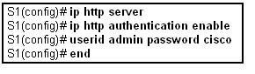
  Refer to the exhibit. After configuring switch S1 with the commands shown, the network administrator can ping the switch correctly but not log in to the HTTP page with the userid and password. What is the likely problem?
  The HTTP server is not enabled.
  The PC does not have the Cisco VPN client software.
  The HTTP server is configured to only accept the enable password.
  The administrator made a typographical error in the userid/password entry.

15 | Principio del formulario
  What are three ways to make a switch less vulnerable to attacks like MAC address flooding, CDP attacks, and Telnet attacks? (Choose three.)
  Enable CDP on the switch.
  Change passwords regularly.
  Turn off unnecessary services.
  Use security tools like DSniff.
  Enable the HTTP server on the switch.
  Use the enable password rather than the enable secret password.
16 | Principio del formulario
  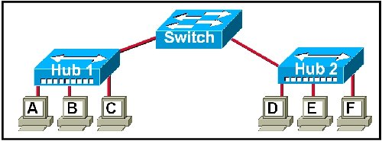
  Refer to the exhibit. How many collision domains exist in the network?
  1
  2
  4
  7
  8
17 | Principio del formulario
  Where is the startup configuration stored?
  DRAM
  NVRAM
  ROM
  startup-config.text

18 | Principio del formulario
  Which command line interface (CLI) mode allows users to configure switch parameters, such as the hostname and password?
  user EXEC mode
  privileged EXEC mode
  global configuration mode
  interface configuration mode
19 | Principio del formulario
  What are three functions of a Layer 2 Ethernet switch? (Choose three.)
  preventing broadcasts
  increasing available bandwidth per user
  decreasing the size of collision domains
  isolating traffic among segments
  routing traffic between different networks
  decreasing the number of broadcast domains

20 | Principio del formulario
  Which two statements are true regarding switch port security? (Choose two.)
  The three configurable violation modes all log violations via SNMP.
  Dynamically learned secure MAC addresses are lost when the switch reboots.
  The three configurable violation modes all require user intervention to re-enable ports.
  After entering the sticky parameter, only MAC addresses subsequently learned are converted to secure MAC addresses.
  If fewer than the maximum number of MAC addresses for a port are configured statically, dynamically learned addresses are added to CAM until the maximum number is reached.
21 | Principio del formulario
  When a collision occurs in a network using CSMA/CD, how do hosts with data to transmit respond after the backoff period has expired?
  The hosts return to a listen-before-transmit mode.
  The hosts creating the collision have priority to send data.
  The hosts creating the collision retransmit the last 16 frames.
  The hosts extend their delay period to allow for rapid transmission.

22 | Principio del formulario
  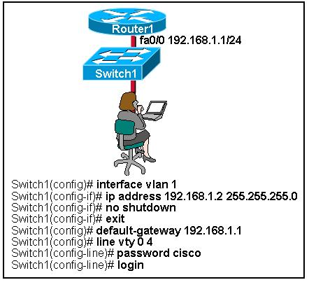
  Refer to the exhibit. What happens when the commands shown are entered?
  The network administrator has supplied the password and requested access to line configuration mode.
  The network administrator can connect directly to the switch for configuration purposes using a crossover cable.
  The network administrator can connect to the switch using the telnet 192.168.1.2 command.
  The network administrator cannot connect to the switch remotely because the default gateway has been configured incorrectly.
23 | Principio del formulario
  A network administrator uses the CLI to enter a command that requires several parameters. The switch responds with "% Incomplete command". The administrator cannot remember the missing parameters. What can the administrator do to get the parameter information?
  append ? to the last parameter
  append a space and then ? to the last parameter
  use Ctrl-P to show a parameter list
  use the Tab key to show which options are available

24 | Principio del formulario
  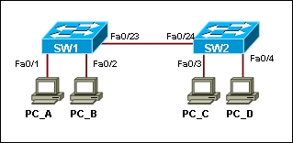
  Refer to the exhibit. How is a frame sent from PC_A forwarded to PC_C if the MAC address table on switch SW1 is empty?
  SW1 floods the frame on all ports on the switch, excluding the interconnected port to switch SW2 and the port that the frame comes from.
  SW1 floods the frame on all ports on SW1, excluding the port that the frame comes from.
  SW1 uses the CDP protocol to synchronize the MAC tables on both switches and after that forwards the frame to all hosts connected to SW2.
  SW1 drops the frame because it does not know the destination MAC address.

Exam Results - ESwitching Chapter 2 - CCNA Exploration: LAN Switching and Wireless - Version 4.0
Domain Knowledge - Weighted Score

Max Points: | 50
Earned Points: | 44
Percentage: | 88.0%

Domain Knowledge - Binary Score

Max Points: | 24
Earned Points: | 21
Percentage: | 87.5%

